STEP 1 : Open Anaconda Prompt Console and activate brain.

STEP 2 : Change the directory to the location where the codes are stored.

STEP 3 : Call the Jupyter Notebook from here.

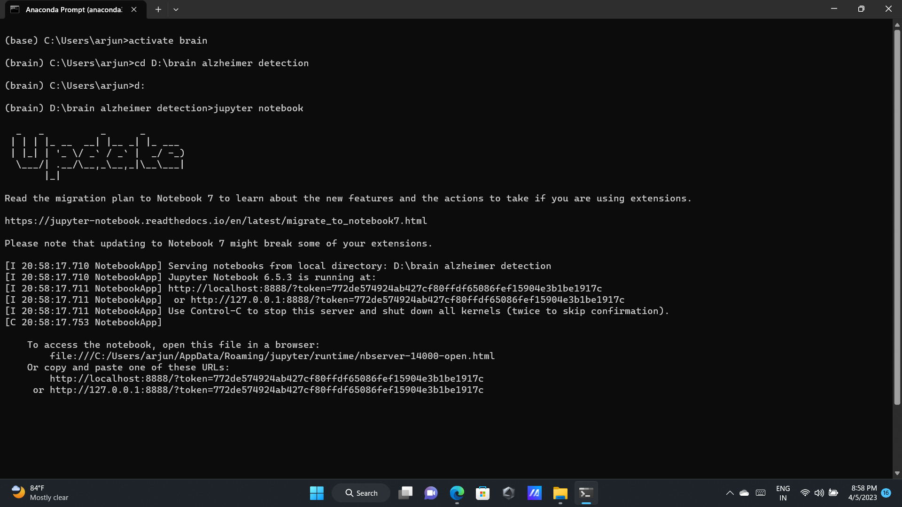

This is the UI of the Jupyter Notebook , Here we can see all our project folders.

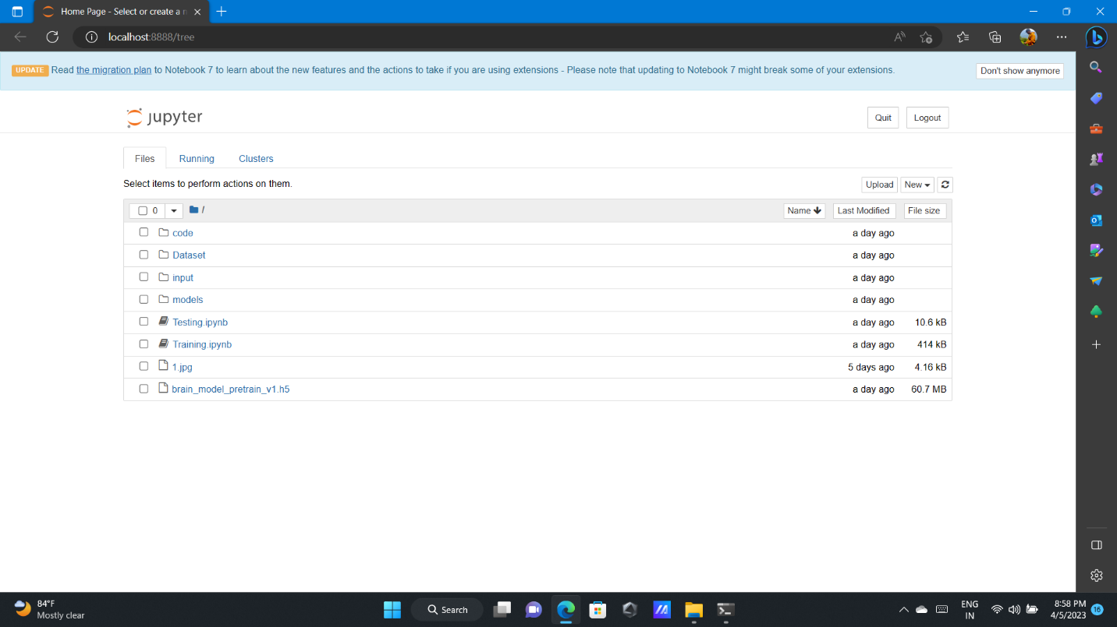

STEP 4 : Run all the cells in the Training folder (module)

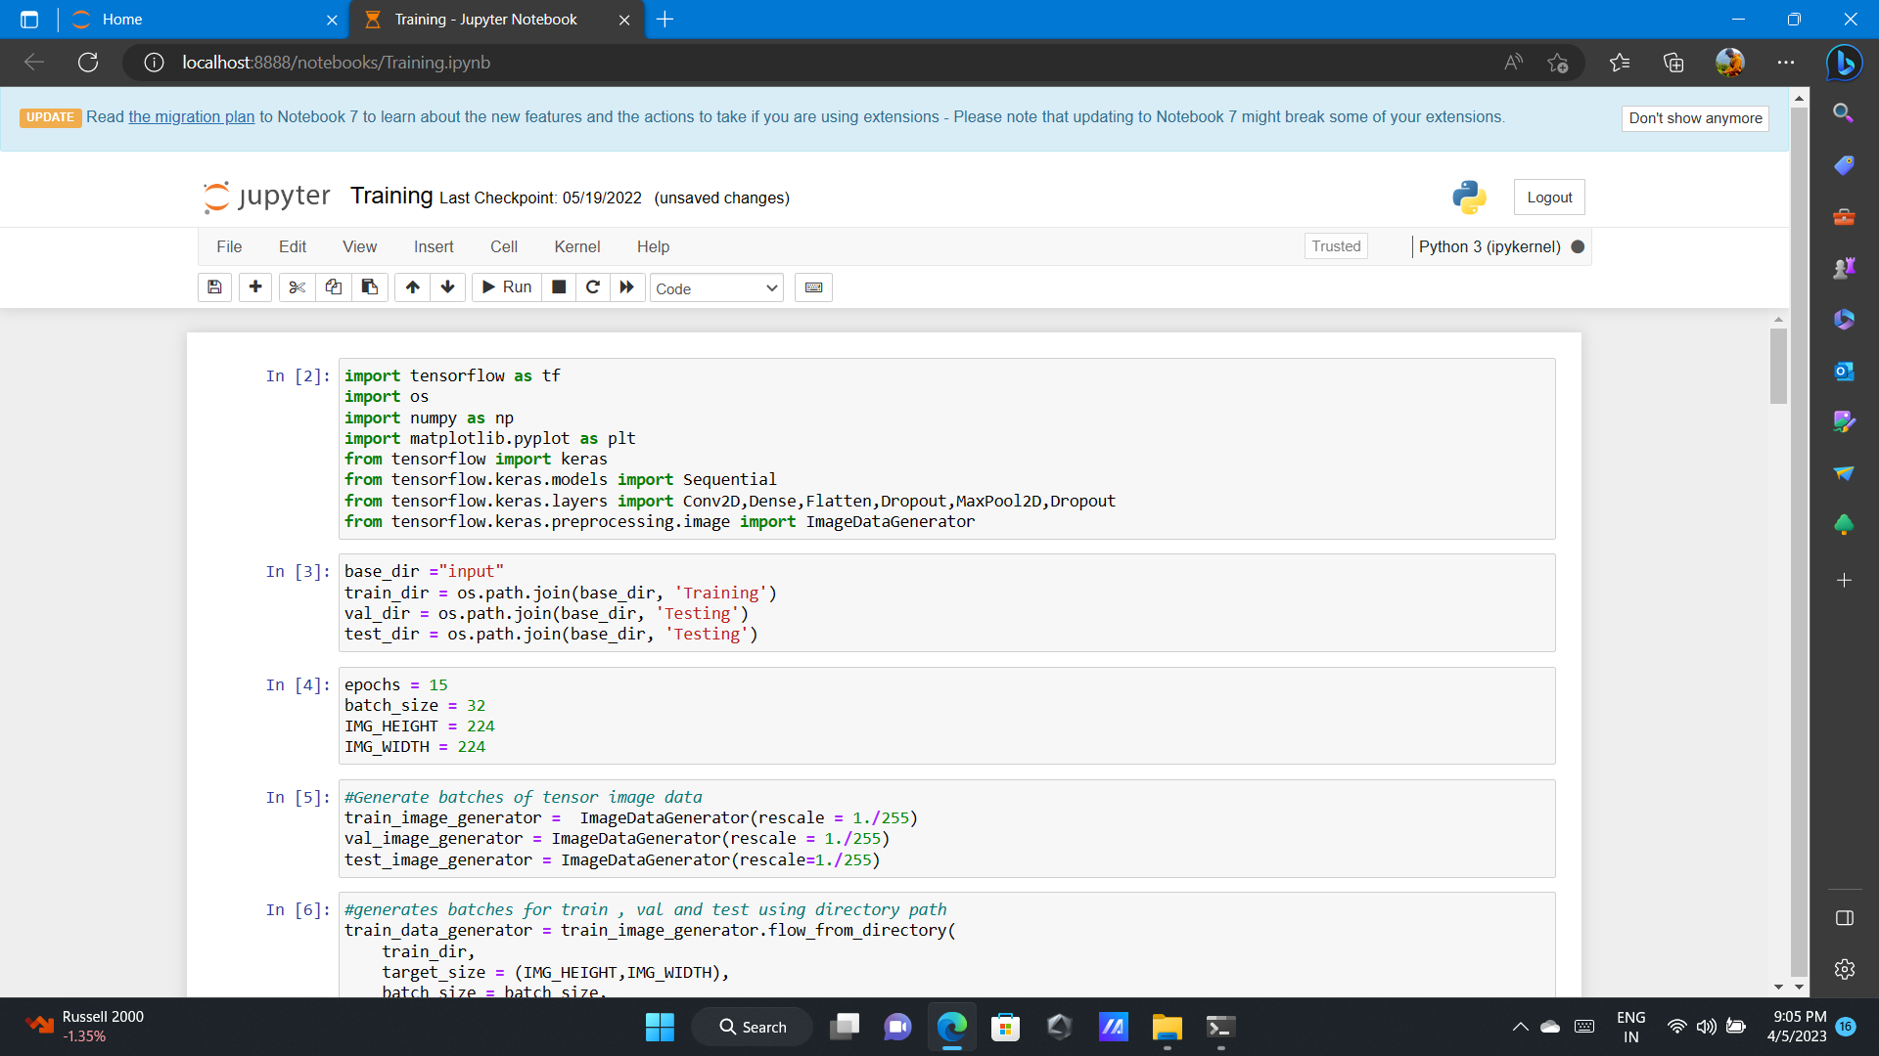

STEP 5 : Run all the cells in the Testing folder (module)

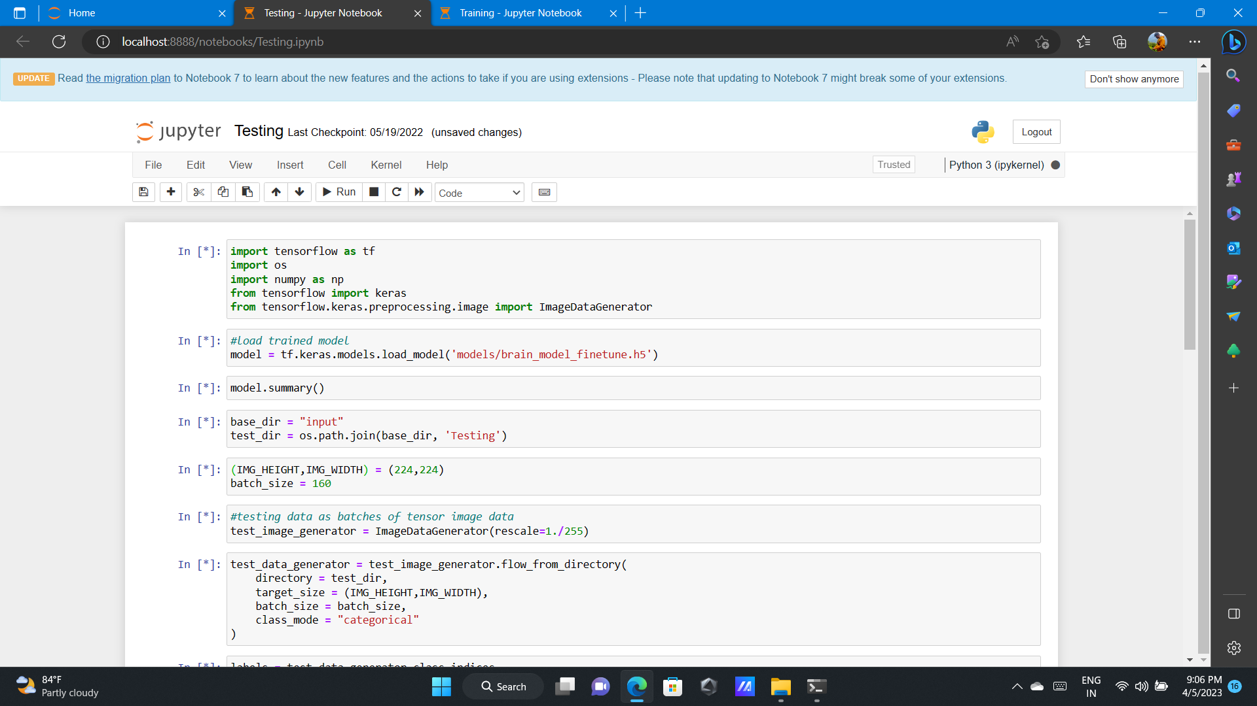

STEP 6 : Now click on the code folder and select the main source file.

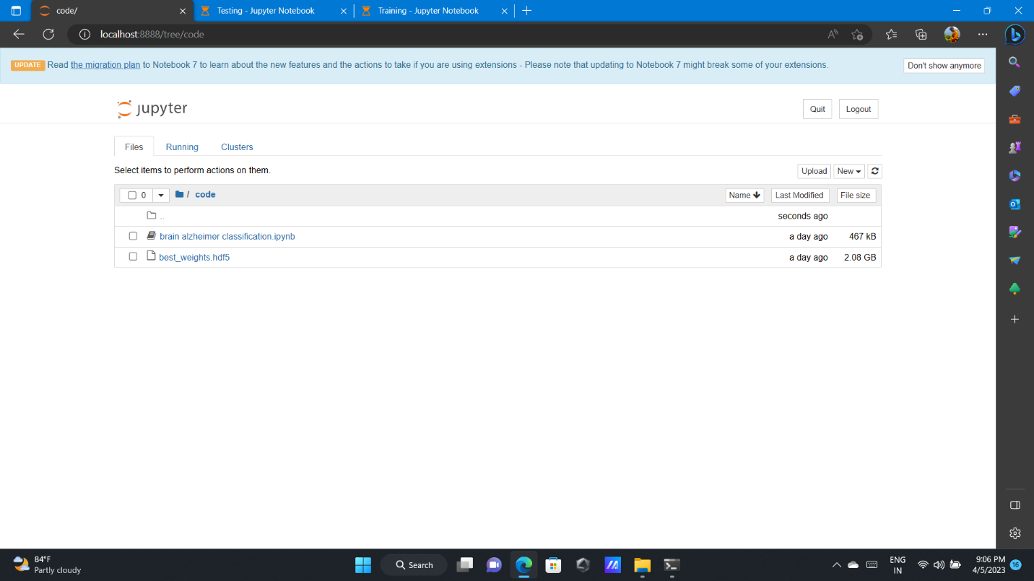

This is how all the Epoches are completed after a successful run.

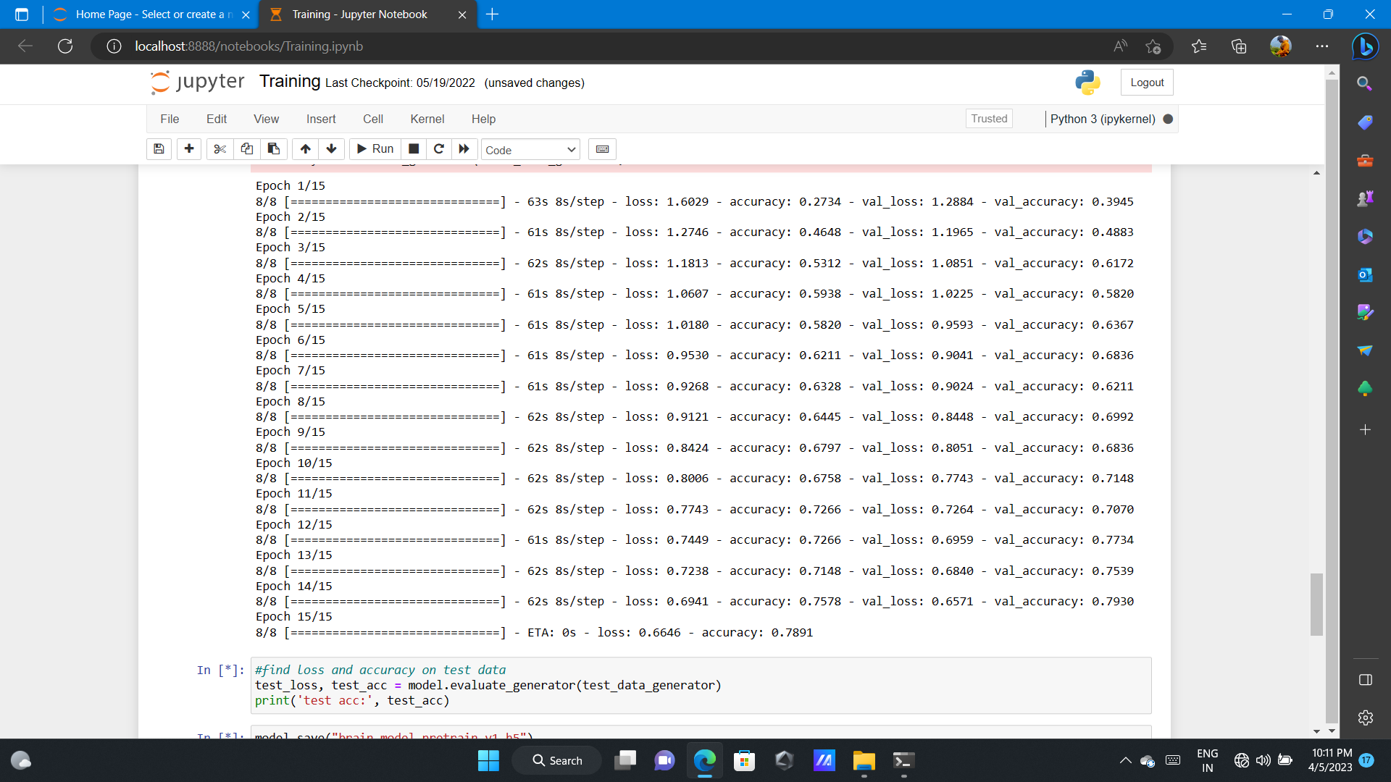

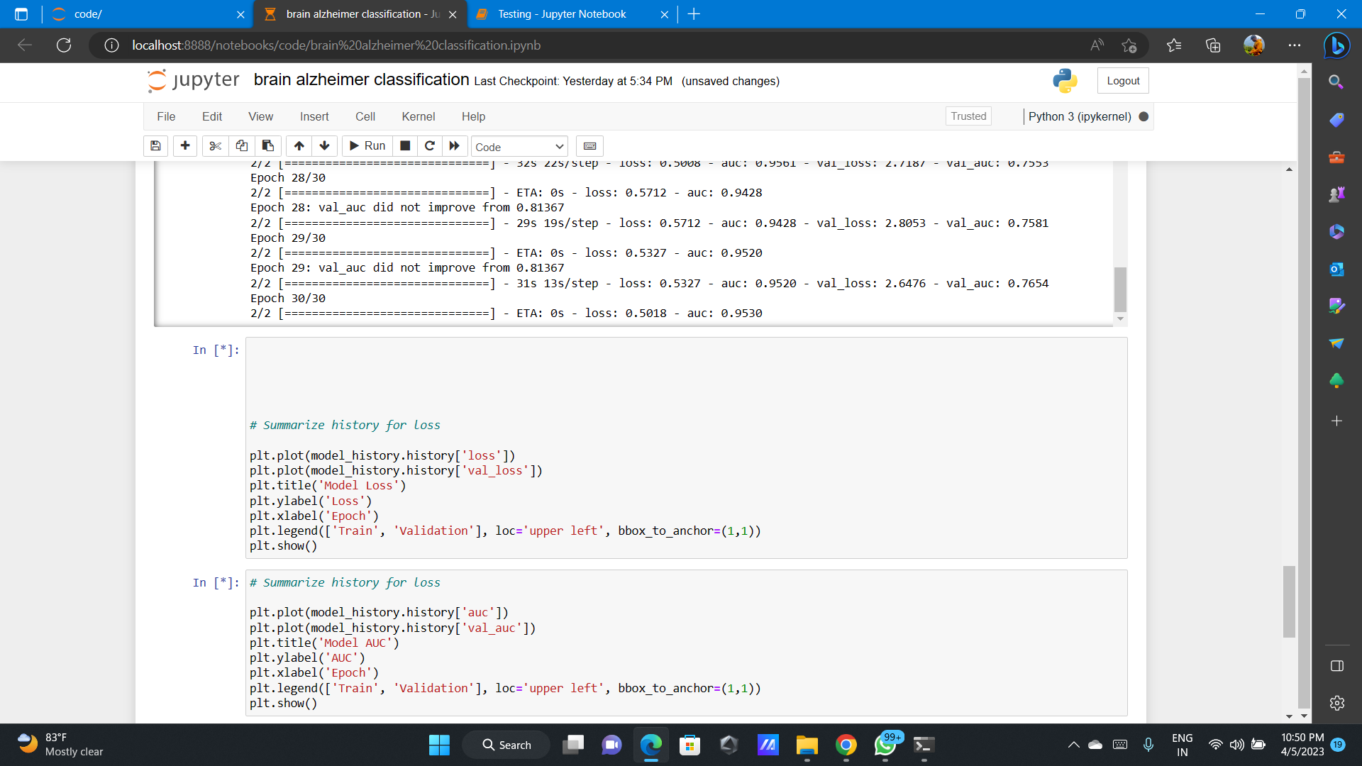

The Train and Validation graph is successfully plotted and shown below (Model Loss)

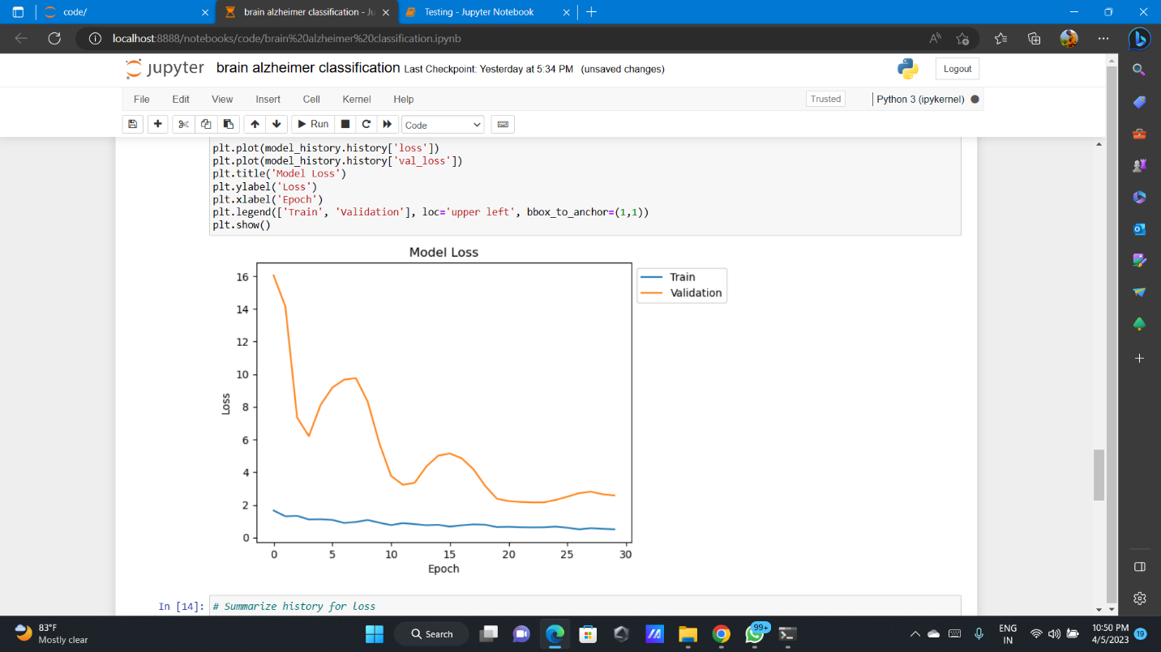

The Train and Validation graph is successfully plotted and shown below (Model Accuracy)

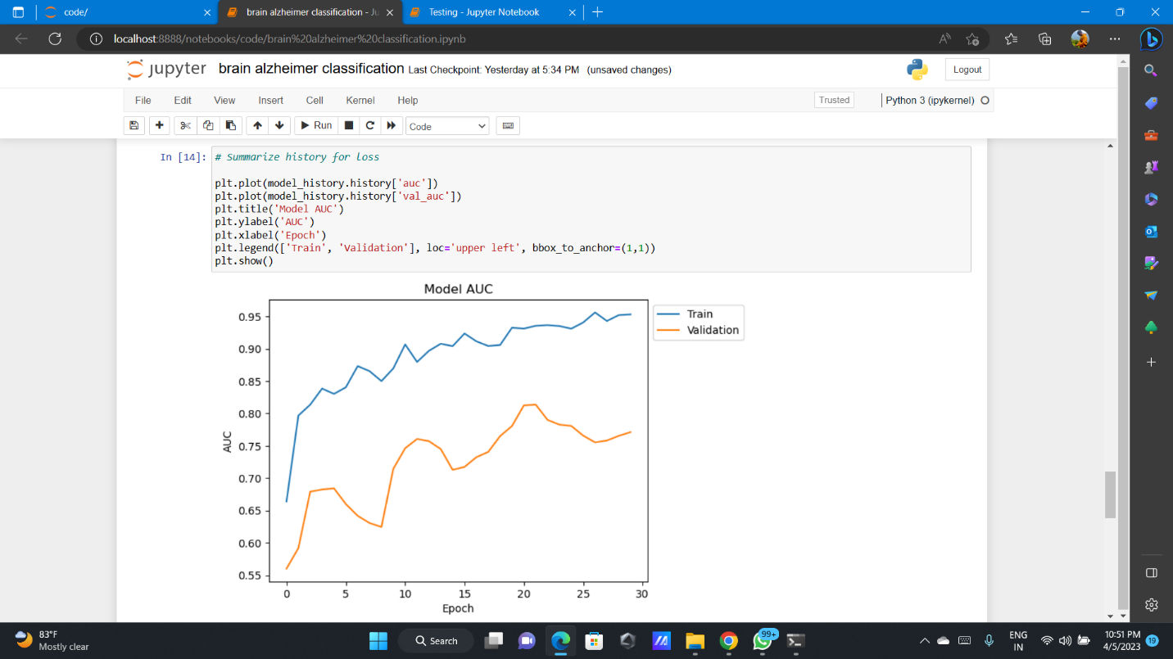

The final successful input and output are shown below

